**DEPARTMENT OF ELECTRONICS & COMMUNICATION ENGINEERING**



**EMBEDDED SYSTEMS**

**Assignment 1**

**Submitted to, Submitted by,**

**Dr. Shireesh Kumar Rai T Raja Aadhithan**

**Asst. Professor 602162021**

**M.Tech (VLSI Design)**

**Task:**

Write Different Programs in ARM assembly language to Set/Reset the flag register and apply all the conditional code suitable to perform the specific task**.**

**Solution:**

The various conditions are mentioned below in the table.

|  |  |  |
| --- | --- | --- |
| **Condition** | **Meaning** | **Flag Status** |
| EQ | equal | Z |
| NE | not equal | Z' |
| CS | carry set/unsigned higher or same | C |
| CC | carry Clear/unsigned lower | C' |
| MI | minus/negative | N |
| PL | plus/positive or Zero | N' |
| VS | overflow | V |
| VC | no overflow | V' |
| HI | unsigned higher | Z'C |
| LS | unsigned lower or same | Z or C' |
| GE | signed greater than or equal | N = V |
| LT | signed less than | N != V |
| GT | signed greater than | Z' (N = V) |
| LE | signed less than or equal | Z' or (N != V) |
| AL | always (unconditional) | ignored |

In the Code there are 15 loops corresponding to 15 conditions above mentioned, only when a condition is satisfied it is moved to a loop on another half of the code. To ensure that any other false path is not taken an unconditional branch to the end of the program is inserted at the middle of the program which force exits the program in case of an error.

Registers R0, R1, R2, R3 is used for compare and arithmetic operations to set/reset the flags. Code R5 displays 0x76396869 only if all the loops are activated. R7 increments by 1 when it enters a loop, hence the value of R7 at the end of the program if successful should be 15 which is 0x0000_000F.

**Code:**

AREA PROGRAM, CODE, READONLY

    ENTRY

MAIN

        MOVS R0, #0

        MOV R1, #1

        SUBS R2,R0,R1

        BMI LOOP1     ;MINUS OPERATION

LOOP2   ADD R7,R7,#1

        SUBS R2,R2,R2

        BEQ LOOP3     ;EQUAL OPERATION

LOOP4   ADD R7,R7,#1

        CMP R3,R2 ;R3-R2

        BHI LOOP5   ;HIGHER OPERATION

LOOP6   MOV R2,#5

        ADD R7,R7,#1

        ADDS R2,R2,#0xFFFFFFFF

        BCS LOOP7     ;CARRY SET

LOOP8   ADD R7,R7,#1

        ADDS R2,R2,#0x0FFFFFFF

        BVC LOOP9     ;OVERFLOW CLEAR

LOOP10  ADD R7,R7,#1

        MOV R3,#1

        MOV R2,#5

        CMP R2,R3

        BGT LOOP11    ;GREATER THAN

LOOP12  ADD R7,R7,#1

        MOV R3,#1

        MOV R2,#5

        CMP R3,R2

        BLT LOOP13      ;LESSER THAN

        BAL LOOP15

LOOP14  ADD R7,R7,#1

        LDR R5,=0x76396869

        BAL LOOP15      ;ALWAYS

LOOP1   ADD R7,R7,#1

        ADDS R2,R2,#5

        BPL LOOP2     ;PLUS OPERATION

LOOP3   ADD R7,R7,#1

        ADDS R3,R2,#1

        BNE LOOP4  ;NOT EQUAL

LOOP5   ADD R7,R7,#1

        CMN R3,R2

        BLS LOOP6     ;LOWER THAN

LOOP7   ADD R7,R7,#1

        ADDS R2,R2,#0xFF

        BCC LOOP8     ;CARRY CLEAR

LOOP9   ADD R7,R7,#1

        LDR R2,=0x7FFFFFFF

        ADDS R2,R2,#1

        BVS LOOP10    ;OVERFLOW SET

LOOP11  ADD R7,R7,#1

        MOV R3,R2

        CMP R3,R2

        BGE LOOP12;GREATER THAN/ EQUAL

LOOP13  ADD R7,R7,#1

        MOV R3,R2

        CMP R3,R2

        BLE LOOP14;LESSER THAN / EQUAL

LOOP15  ADD R7,R7,#1

        ADDS R0,R0,R0   ;TO END

LOOP32  B LOOP32

        END

**Output:**

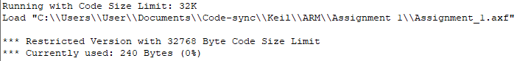

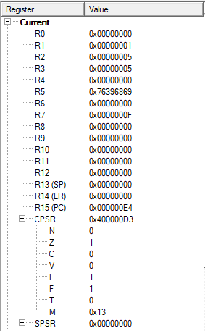

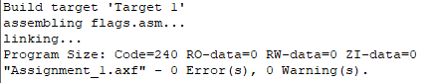

**Result:**

The output of the registers is as expected hence we can conclude that the program has run as expected.